Chapter # 5 Testing
5.1 About testing
Testing is the process by which software quality can be assured and requirements can be enforced, software written with tests are higher quality and contain lesser design bugs
5.2 unit testing
unit testing is the process of writing assertions and other tests in order to make sure the code performs the way it is supposed to for example if there is a function that does addition then test data will check to see if the addition of two known quantities is a known result e.g 2+2 should return 4 for the function to be correct. Testing is very essential to enforce requirements and produce high quality code. Applications containing user entered data can be unit tested and there exist different tools and method to test other types of applications.

5.3 Test driven development
One approach of unit testing promotes the idea of writing tests before any code is written and then writing code which will make these tests true, this way all the requirements can be forced in form of tests and one can not write code that breaks the requirements.

5.4 Testing with mock objects and fakes
Complex user controls and framework hierarchies need something other than unit testing in order to be tested, mock object are fake objects which emulate real objects and actions performed on them. Mocks or mock objects are used in situations where it would other wise be infeasible or even impossible to test an application. A part of application which needs testing can be simulated and tested alone, system supplied components are already tested by the vendor and do not need any further testing.

5.6 A tutorial on test driven development in visual studio 2012
Below is a tutorial published on the visual studio magazine by “Mickey gousset” on 07/09/2013 and the author of this document gives all the due credits to Mickey gousset.

There are various ways to build and test software. The specific process followed depends on a variety of factors, including the project itself, team members, project schedule and so on. One such process is termed Test-driven Development (TDD). In TDD, I develop test cases before I write any code. Once I have test cases in place, then I can build the appropriate functionality to make the tests pass.
This is a reverse of the standard coding model, where code is developed first, then tested. But this method has several benefits:
- The ability to tackle small aspects of the system initially, and evolve the system as the requirements evolve
- The tests act as documentation for the system
- The tests serve as a suite of regression tests, ensuring that future code changes don't break existing functionality
Visual Studio 2012 supports the concept of TDD through its unit testing framework. In this column, I'll walk through a simple example of using Visual Studio 2012, and its unit testing framework, to perform TDD. My scenario is building a windows class library for performing math functions, such as addition and subtraction.
To begin, create a blank solution in Visual Studio 2012 named ALM.UnitTestingExample. Add a new C# Windows Class Library project to the solution, and name it ALM.MathLibrary. This project will contain the code for performing the math functions. Now add a C# Windows Unit Test Project to the solution, and name it ALM.MathLibraryTests. A Test Project is a Visual Studio project that contains various tests, such as unit tests and web tests, and will contain the tests designed for the math library. Delete the Class1.cs file from the ALM.MathLibary project, and the UnitTest1.cs file from the ALM.MathLibraryTests project. Finally, add a reference to the ALM.MathLibrary project, from the ALM.MathLibraryTests project.
With the base solution now in place, I can start building the tests. This is a math library which will have functions for addition and subtraction. Right-click on the ALM.MathLibraryTests project, and select Add | New Item. Select the Unit Test object, and name it BasicMathFunctionsTest.cs. This creates a new class file to contain all tests related to basic math functions. Figure 1 shows what the base generated code for this class looks like.
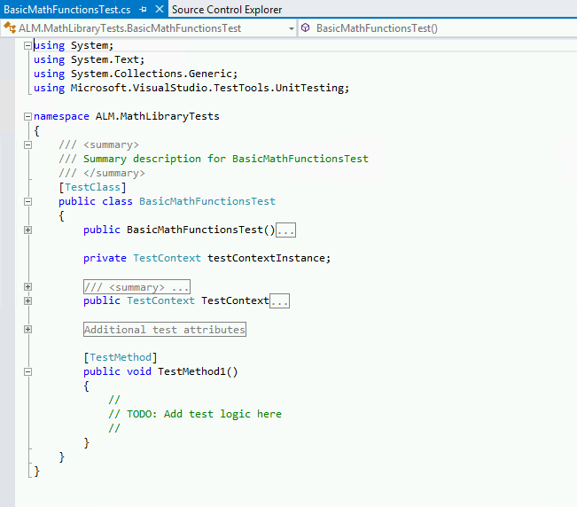
Figure 1. The base generated code for a unit test.
Notice the different attributes in the code. Above the class declaration is a [TestClass] attribute. This marks this class as a test class containing test methods, which allows the unit testing framework to pick it up. The generated code also created a sample test method for me, named TestMethod1. This method is also marked with an attribute, [TestMethod]. This attribute allows the testing framework to identify this method as a potential test that needs to be run. Rename TestMethod1 to be AddTest. Right-click on the solution in Solution Explorer and select Build Solution to verify the solution will build.
At this point I have a test project, with a test class and a blank test method. Just for fun, let's run this test and see what happens. Visual Studio 2012 has a window called Test Explorer for interacting and running unit tests. In Visual Studio, select Test | Windows | Test Explorer to open this window, shown in Figure 2.
Figure 2. The AddTest Method, with test code added.
When the test project was compiled, the testing framework found the test class and method definitions, and displays the tests in the Test Explorer window. In this scenario, it knows this test has not been run yet, so it lists it under the Not Run Tests category. There are multiple options for running tests. I can right-click on a specific test and run just that test. I can run an entire category of tests. Or I can run all the tests listed in the Test Explorer. Click the Run All link to run all the tests. The solution will be built, and the test will run, with the results showing at the bottom of the test window. In this scenario, the test will pass, as there's no actual test to run. Notice also that the test was moved to the Passed Tests category in Test Explorer.
Now let's build an actual test. As Figure 3 shows, I've added code to the AddTest method.
Figure 3. The AddTest Method, with test code added.
For this test, I'm instantiating a class called BasicMathLibrary. I'm going to be testing the Add function of the library, so I specify the expected value, then make a call to the Add method. Finally, I use the Assert.AreEqual method to check whether or not the expected value matches the actual value returned from the Add method. However, if I build the solution, the build will fail (obviously) because I haven't created the BasicMathLibrary class or the Add method. So, following test-driven development principals, I should create the class and the method, as shown in Figure 4.
Figure 4. The created class and method, based off the test code.
Notice how I've created the BasicMathLibrary class and the Add method, but haven't built any functionality yet for the Add method. Instead, I am throwing a NotImplementedException exception. This allows me to quickly stub out methods without adding actual logic, to allow my solution and tests to compile.
With the class and method stubbed out, build the solution again. At this point, the solution should compile correctly. Go back to the Test Explorer and click the Run All link. The AddTest will run, and this time will fail, as shown in Figure 5.
Figure 5. The Test Explorer window, showing that the AddTest test has failed.
Figure 5 shows the AddTest unit test failed, and gives me details around the failure. In this instance, it tells me that the method or operation isn't implemented, which is what was expected. From here, I can go back to the Add method, implement the appropriate code, then re-run the test. Once that test passes, I create the next unit test, and then go through the same process as outlined earlier.
TDD is a proven methodology for building software that helps ensure the source code is thoroughly unit tested. And Visual Studio 2012, with its unit testing framework, provides the ability to easily implement test-driven development in an organization. In Part 2 of this column, I will continue to build off this example, and show in more detail how to use the unit test framework in Visual Studio 2012

In Part 1 of this column, I defined test-driven development (TDD), why it's important, why it's a successful development methodology, and the basics of how to implement TDD using the unit testing framework in Visual Studio 2012. In this column, I'm going to continue to build off the example code in Part 1, and continue to dive into the unit testing framework in Visual Studio 2012, specifically the different features provided by Test Explorer to help with the testing process.
When I left off last time, I'd created the stub code for the Add method and run the unit test for the method. The test failed because the code hadn't been implemented yet. This implies that I need to implement the actual method. I can add the following line of code to the method to implement the logic:
return (p1 + p2);
Open the Test Explorer window, and click the Run All link to run all the unit tests. The solution will compile and the tests will run. This time the test will pass, as expected.
Let's dive into the Test Explorer window in more detail. The Test Explorer window is my interface into the unit tests in my solution. The Test Explorer window, by default, groups my tests into multiple categories, such as Failed Tests, Not Run Tests and Passed Tests. This lets me easily see new tests that have been created but not yet executed, so I can run just those tests in a test run. To see this, add a new test method, SubtractTest, to the BasicMathFunctionsTest class, as shown in Figure 1.
Figure 1. The SubtractTest test method.
As can be seen in Figure 1, a new method was added to the BasicMathFunctionsTest.cs class, called SubtractTest. If I compile the solution, the unit test framework will pick up on the new test method and add it to the Test Explorer window under the Not Run Tests category, as shown. This provides a quick and easy way to see what new tests are available.
Notice how the method currently contains one line of code, Assert.Inconclusive(). If I just create the test method without any code and run it, it would pass. While this is perfectly valid, it doesn't help me identify any test stub methods I might have created, i.e. test methods where I just created the shell of the method, with the intention of adding the actual test code later. Adding an Assert.Inconclusive() call to any unfinished test method will cause that test method to show up as skipped in the Test Explorer window (Figure 2). Any methods showing up as skipped would indicate test methods that need to be modified/created.
Figure 2. Tests that need to be implemented will show up as skipped in Test Explorer.
The Test Explorer window can be used to organize tests into Test Playlists. Right-click on a test, and select Add to Playlist | New Playlist to create a new playlist file. This creates an XML file with a .PLAYLIST extension, containing the names of all the tests in that playlist. I can now select the Playlist drop down box in the Test Explorer window and select the created playlist. This will display in Test Explorer only the tests contained in the playlist. To see all the tests available in a solution, click the Playlist drop down box again and select All Tests.
By default, the tests in Test Explorer are arranged by test outcome, such as passed, failed or skipped. You can also arrange them by test class, test duration or test project.
Another methodology starting to appear is the idea of continuous testing. The idea is that I should be continuously testing my code as I build it. Visual Studio 2012 supports this by allowing me to automatically run my unit tests as part of my personal build process. Instead of building my solution and then opening Test Explorer and running my tests, I can have the tests run automatically as soon as I build the solution. This saves time, as well as providing immediate feedback on the build process. To do this, click the Run Tests After Build button in the top left of the Test Explorer.
The past two columns have delved into how to perform TDD using Visual Studio 2012, and a more in-depth look into the Test Explorer window. Visual Studio 2012 provides many more testing opportunities for TDD, from the use of other testing frameworks to the use of shims and fakes to help mock out code to test. All of these tools can be used to help create better-tested code.

About the Author
Mickey Gousset spends his days as a principal consultant for Infront Consulting Group. Gousset is lead author of "Professional Application Lifecycle Management with Visual Studio 2012" (Wrox, 2012) and frequents the speaker circuit singing the praises of ALM and DevOps. He also blogs at ALM Rocks!. Gousset is one of the original Team System/ALM MVPs and has held the award since 2005.

